Assignment 1
Step 1
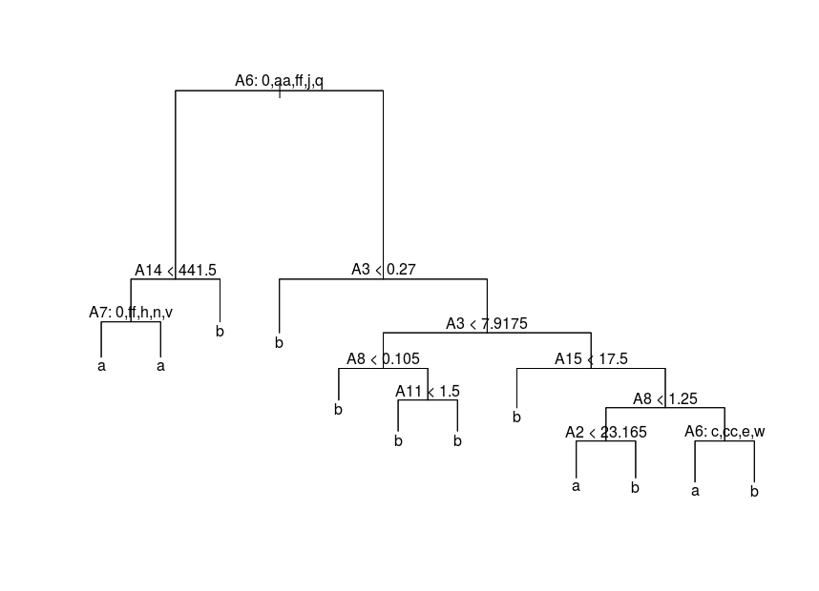
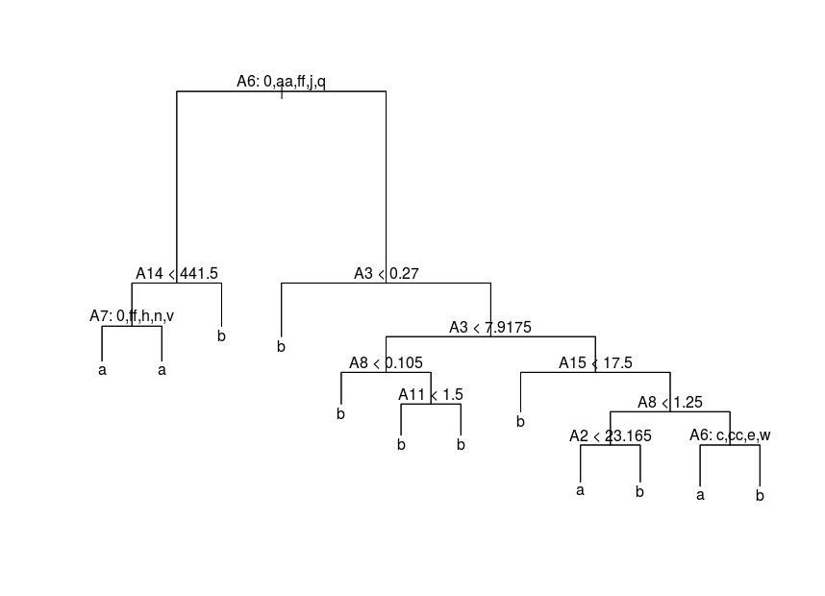

*Trees are wrong, model is misspecified
The first Figure is when we use all observations and the second Figure is when we remove the second observation. As we can see so has nothing changed however if we were to remove another observation we can see that the tree changes. For example by removing the first observation instead as we can see in the following Figure.
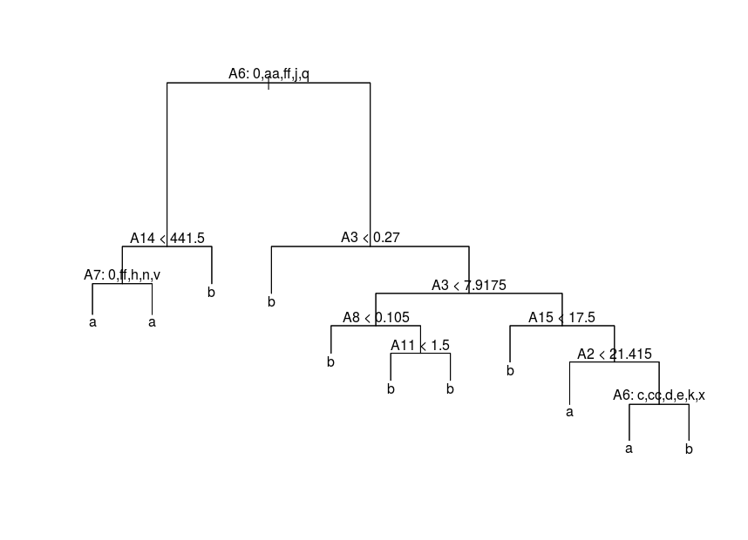
As we can see here so have the tree changed a little bit. Why this change may be is because that observation variable can have a large impact on the data which is why removing observation 2 did not change anything since that observation did not have a large impact on the data. What this means is that some observations in the data set deviates a lot from the other observations and thus by removing it will change the overall result pretty much in some features. This is why we can see that only part of the tree has changed when removing observation 1 since those features rests “heavy” on the first observation while when removing observation 2 those features do not impact the data that much since it is very similar to the overall observations. *Wrong motivation
*0.5p
Step 2
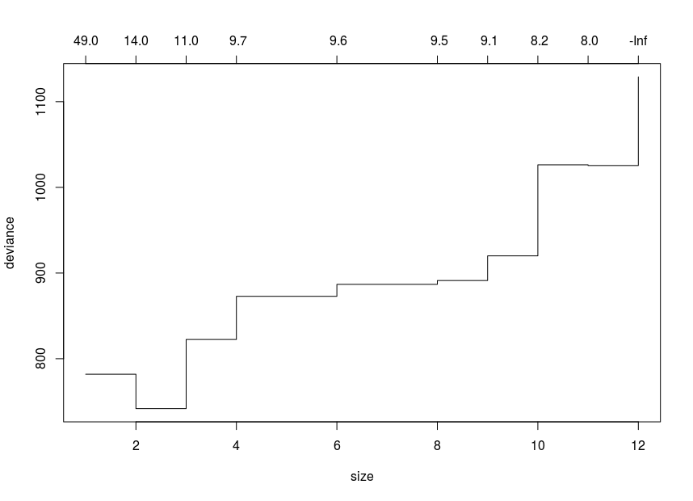
The optimal tree should have 2 or 3 leaves since it gives the lowest deviance. The less the data deviates the better the model is. The variable selected by the optimal tree were 2 and those are a and b. The optimal tree is the following. *Wrong
*2p

Step 3*Wrong family selected→ results are wrong
The cross-validation plot is the following Figure.
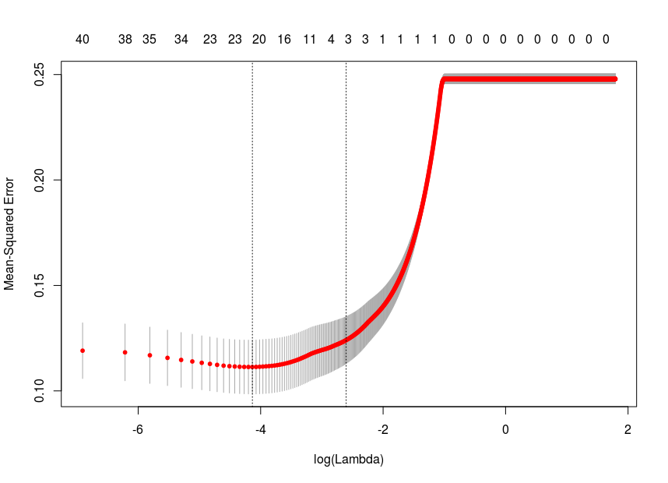
The optimal penalty parameter value is 0.016 and the number of components selected is 22. By looking at the cross-validated LASSO I can definitely say that the optimal model looks significantly better than the model with the smallest penalty parameter. *Wrong
*1p

Assignment 2
Step 1
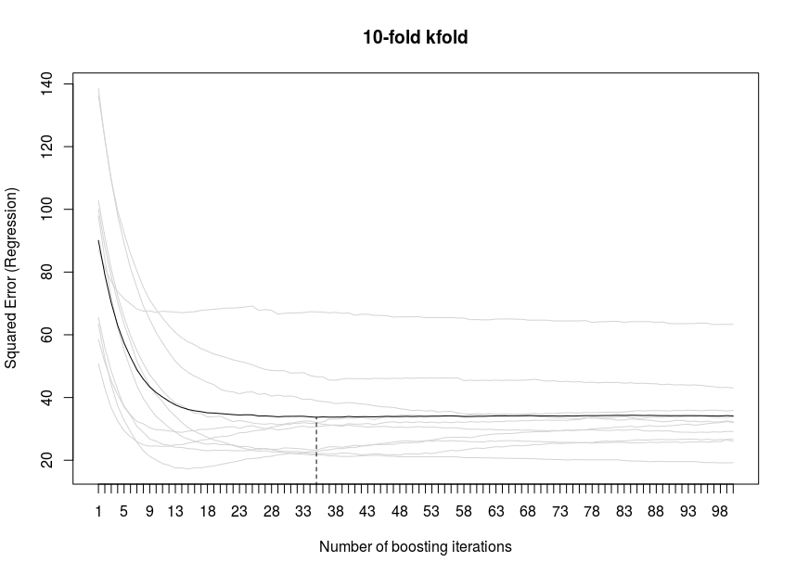
What the above plot says is that for more is to see for how many iterations of boosting will give the best model by looking at arbitrary loss functions. In this case 35 is the optimal number of iterations.

0p Unreadable. Moreover, what does “arbitrary loss functions” mean ?

Appendix
Assignment 1
############
###Step 1###
############
data = read.csv('crx.csv')
n=dim(data)[1]
set.seed(12345)
id=sample(1:n, floor(n*0.8))
train=data[id,]
id1=setdiff(1:n, id)
set.seed(12345)
test=data[id1,]

library(tree)
tree_model = tree(data=train)WRONG HERE
plot(tree_model)
text(tree_model,pretty=0)

newtrain = train[2:552,]
newtrain[1,] = train[1,]
tree_model2 = tree(data=newtrain)
plot(tree_model2)
text(tree_model2,pretty=0)

newtrain = train[2:552,]
tree_model2 = tree(data=newtrain)
plot(tree_model2)
text(tree_model2,pretty=0)

############
###Step 2###
############
cv.tree_model = cv.tree(tree_model)
best.size = cv.tree_model$size[which(cv.tree_model$dev==min(cv.tree_model$dev))]
cv.tree_model.pruned = prune.tree(tree_model, best=best.size)

plot(cv.tree_model.pruned)
text(cv.tree_model.pruned,pretty=0)

############
###Step 3###
############
library(glmnet)
x_train = model.matrix( ~ .-1, train[,-16])

set.seed(12345)
model=cv.glmnet(x_train,train$Class, alpha=1,family="gaussian",lambda = seq(0,2,0.001))
model$lambda.min
plot(model)
coef(model, s="lambda.min") #22 variables

############
###Step 4###
############
error_func = function(model){
target = test$Class
pred = predict(tree_model,test)
pred = pred[,3]
for (i in 1:length(pred)) {
if(pred[i] == 1){
pred[i] = 2
}
}
E = target*log(pred) + (1-target)*log(1-pred)

}

tree_error = error_func(tree_model)

Assignment 2
############
###Step 1###
############
library(mboost)
bf <- read.csv2("bodyfatregression.csv")
set.seed(1234567890)
m <- blackboost(Bodyfat_percent~Waist_cm+Weight_kg, data=bf)
mstop(m)
cvf <- cv(model.weights(m), type="kfold")
cvm <- cvrisk(m, folds=cvf, grid=1:100)
plot(cvm)
mstop(cvm)

############
##Step 2-3##
############
library(kernlab)
data = read.csv('spam.csv')
index <- sample(1:dim(data)[1])
train <- data[index[1:floor(dim(data)[1]/2)], ]
test <- data[index[((ceiling(dim(data)[1]/2)) + 1):dim(data)[1]], ]

filter1 <- ksvm(type~.,data=train,kernel="rbfdot",
kpar=list(sigma=0.01),C=1,cross=2)

mailtype1 <- predict(filter1,test[,-58])

filter2 <- ksvm(type~.,data=train,kernel="rbfdot",
kpar=list(sigma=0.05),C=1,cross=2)

mailtype2 <- predict(filter2,test[,-58])

filter3 <- ksvm(type~.,data=train,kernel="rbfdot",
kpar=list(sigma=0.05),C=5,cross=2)

mailtype3 <- predict(filter3,test[,-58])

filter4 <- ksvm(type~.,data=train,kernel="rbfdot",
kpar=list(sigma=0.01),C=5,cross=2)

mailtype4 <- predict(filter4,test[,-58])

filter5 <- ksvm(type~.,data=train,kernel="vanilladot",C=1,cross=2)

mailtype5 <- predict(filter5,test[,-58])

filter6 <- ksvm(type~.,data=train,kernel="vanilladot",C=5,cross=2)

mailtype6 <- predict(filter6,test[,-58])

missclass=function(X,X1){
n = length(X)
return(1-sum(diag(table(X,X1)))/n)
}

miss1 = missclass(mailtype1,test$type)
miss2 = missclass(mailtype2,test$type)
miss3 = missclass(mailtype3,test$type)
miss4 = missclass(mailtype4,test$type)
miss5 = missclass(mailtype5,test$type)
miss6 = missclass(mailtype6,test$type)

missdata = c(miss1,miss2,miss3,miss4,miss5,miss6)
which.min(missdata)

1.5p You cannot use the test data to select the model

